Installation Procedure for:
Master Processor in
PT 5210 VariTime� Digital Sync Generator

The master processor in the PT 5210 VariTime™ Digital Sync Generator can be installed by technical qualified users.
Exchange of the master processor is typically only required for configuration of special versions.

- Open the PT 5210 by removing the top cover.
- Identify the master processor on the processor module mounted flat behind the display module.
- By use of suitable IC extractor remove the master processor.
- Insert the new processor. Take care to orientate the processor correctly.
- Mount the top cover on the PT 5210.
- Perform a factory reset: While pressing the three buttons ARROW RIGHT and ARROW LEFT simultaneously turn on the power.
- Observe that the menu includes the changes to the SDI test signal generator menu.
- Place the option type plate on the side of the generator in order to make later identification possible
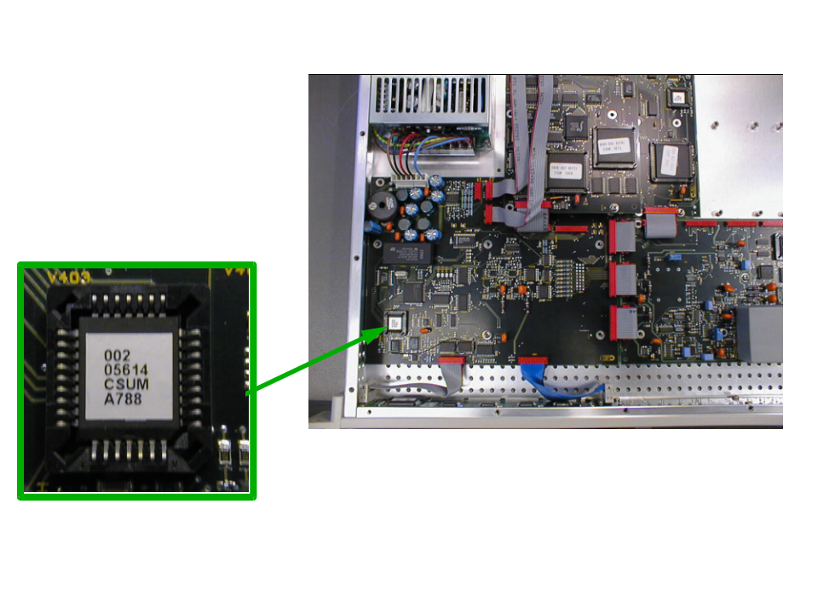
Picture 1: The positioning of the master processor. The lower right corner on the processor is indicated by a cut in the chip.
Note: The numbers on the prom is the numbers on the standard version.

